INTERNSHIP PROJECT REPORT
Title
Influencer Campaign Performance Tracker using Python and Power BI
Submitted By:
Name: Madhumitha V
Project Title: Influencer Campaign Performance Tracker
Tools Used: Python (Jupyter Notebook), Pandas, NumPy, Matplotlib, Seaborn, Power BI
Dataset: Influencer Marketing ROI Dataset (Kaggle)

1.Abstract:
Influencer marketing has become one of the most effective digital marketing strategies for promoting products and services. However, organizations often face challenges in measuring campaign performance, identifying successful influencers, and evaluating the return on investment (ROI).

This project develops an Influencer Campaign Performance Tracker using Python for data preprocessing and Power BI for interactive visualization. The dashboard enables marketing teams to monitor campaign performance, compare influencer categories, analyze platform effectiveness, evaluate ROI, and optimize marketing spending through data-driven insights.

2.Objectives
The objectives of this project are:
- To clean and preprocess influencer marketing campaign data.
- To calculate important business KPIs.
- To analyze influencer performance across different platforms.
- To evaluate campaign profitability using ROI.
- To segment influencers based on campaign performance.
- To build an interactive Power BI dashboard for business decision-making.

3.Dataset Description
The dataset contains influencer marketing campaign information collected from multiple social media platforms.
Dataset Columns
- campaign_id
- platform
- influencer_category
- campaign_type
- start_date
- end_date
- engagements
- estimated_reach
- product_sales
- campaign_duration_days
Derived Columns Created
- Campaign_Cost
- Revenue
- ROI
- Engagement_Rate
- Cost_Per_Engagement
- Conversion_Rate
- Audience_Group
- ROI_Group
- Influencer_Type
- Engagement_Group
- Cost_Efficient

Software Requirements
- Python 3.x
- Jupyter Notebook
- Pandas
- NumPy
- Matplotlib
- Seaborn
- Power BI Desktop

4.Phase 1 :Data Cleaning
The first phase focused on preparing the dataset for analysis.
The following preprocessing tasks were completed:
- Imported the dataset into Jupyter Notebook.
- Checked dataset information.
- Identified missing values.
- Removed duplicate records.
- Converted date columns into datetime format.
- Verified data types.
- Cleaned inconsistent values.
- Saved the cleaned dataset.
Outcome:
The dataset became clean, consistent, and ready for analysis.

5.Phase 2:KPI Design
Business Key Performance Indicators (KPIs) were calculated to evaluate campaign performance.
The following KPIs were created:
- Total Campaigns
- Total Reach
- Total Revenue
- Total Campaign Cost
- Average ROI
- Average Engagement Rate
- Cost Per Engagement
- Conversion Rate
These KPIs provide an overview of overall marketing performance.

6.Phase 3: Analytics Investigation
Exploratory Data Analysis (EDA) was performed to understand campaign performance.
The following analyses were completed:
- Platform vs Engagement
- Influencer vs Revenue
- Campaign Cost vs ROI
- Followers/Reach vs Revenue
- Audience Group vs Performance
- KPI Cards
- Bar Charts
- Scatter Plots
- Heatmaps
- Funnel Analysis
The analysis identified relationships between campaign investment, engagement, reach, and revenue.

7.Phase 4:Influencer Segmentation
Influencers were categorized into meaningful business groups.
The following segments were created:
High ROI Influencers
Campaigns with ROI above the average were classified as High ROI Influencers.
Micro Influencers
Influencers with relatively lower estimated reach.
Mega Influencers
Influencers with higher estimated reach.
High Engagement Creators
Influencers having engagement rates above the average.
Cost Efficient Influencers
Influencers with lower Cost Per Engagement compared to the dataset average.
These segments help businesses identify the most valuable influencers for future campaigns.

8.Phase 5:Dashboard Development
An interactive Power BI dashboard was created consisting of four pages.

Page 1 – Executive Overview
KPIs:
- Total Campaigns
- Total Reach
- Total Revenue
- Total Spend
- Average ROI
- Average Engagement
Charts:
- ROI Trend
- Revenue Trend
- Campaign Success
Slicers:
- Platform
- Campaign Type
Page 2 – Influencer Dashboard
Charts:
- Influencer vs Revenue
- Influencer vs Reach
- Influencer vs ROI
- Micro vs Mega Influencers
Slicers:
- Platform
- Influencer Category
Page 3 – Platform Dashboard
Charts:
- Platform vs Engagement
- Platform vs Reach
- Platform vs Conversion
- High Engagement Creators
Slicers:
- Platform
- Campaign Type

Page 4 – Financial Dashboard
Charts:
- Spend vs Revenue
- ROI Analysis
- Cost Efficiency
Slicers:
- ROI Group
- Platform

9.Business Insights
The dashboard provides several valuable insights:
- Different platforms generate different engagement levels.
- Campaign revenue varies across influencer categories.
- High campaign cost does not always produce higher ROI.
- Cost-efficient influencers often generate better marketing value.
- Audience segmentation improves campaign targeting.
- ROI analysis helps optimize future marketing investments.

10.Business Recommendations
Based on the analysis, the following recommendations are suggested:
- Invest more in High ROI influencers.
- Focus marketing campaigns on platforms with higher engagement rates.
- Increase collaboration with Cost Efficient influencers.
- Improve campaigns with lower conversion rates.
- Use audience segmentation for personalized marketing strategies.
- Continuously monitor campaign KPIs using Power BI dashboards.

11.Conclusion
The Influencer Campaign Performance Tracker successfully analyzed influencer marketing campaign performance using Python and Power BI. The project transformed raw campaign data into meaningful business insights through data cleaning, KPI design, exploratory analysis, influencer segmentation, and interactive dashboards.

The developed dashboard enables organizations to evaluate campaign effectiveness, compare influencer performance, optimize marketing budgets, and make informed business decisions based on data. This project demonstrates the practical application of data analytics and business intelligence in digital marketing.

12.References
- Kaggle – Influencer Marketing ROI Dataset
- Pandas Documentation – https://pandas.pydata.org
- NumPy Documentation – https://numpy.org
- Matplotlib Documentation – https://matplotlib.org
- Seaborn Documentation – https://seaborn.pydata.org
- SciPy Documentation – https://scipy.org
- Python Official Documentation – https://www.python.org
- Jupyter Notebook Documentation – https://jupyter.org
- Microsoft Power BI Documentation

13. Github Repository link:
https://github.com/Madhumitha242005/Influencer-Campaign-Performance-Tracker.git

14.RESULT:
PHASE:1
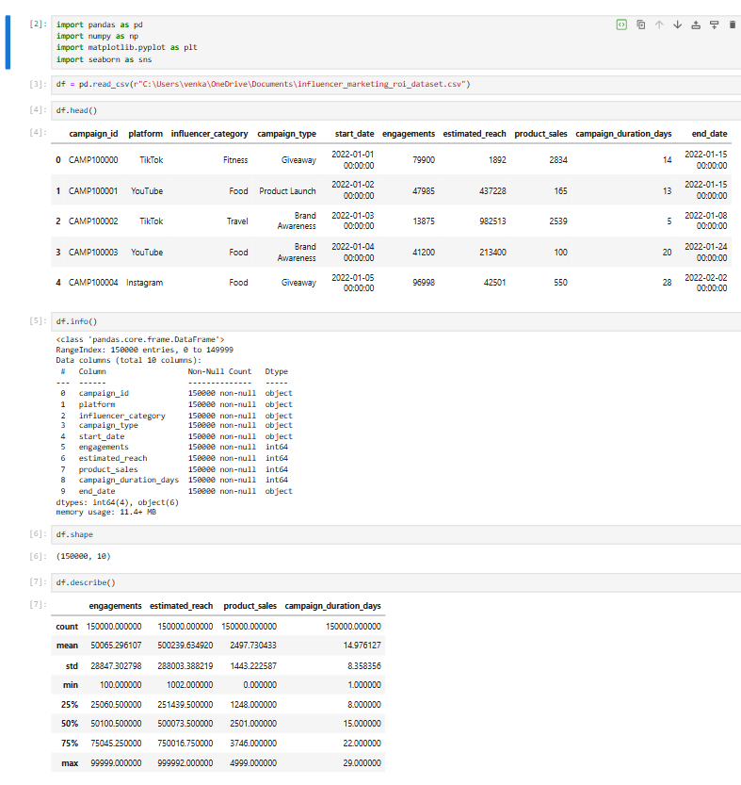

PHASE:2
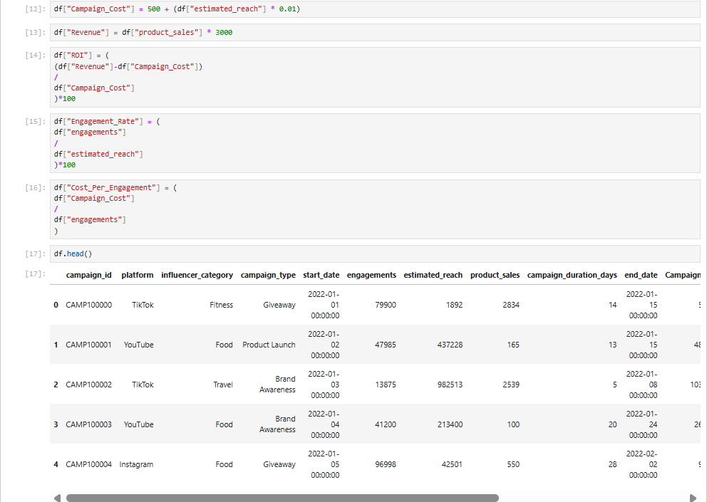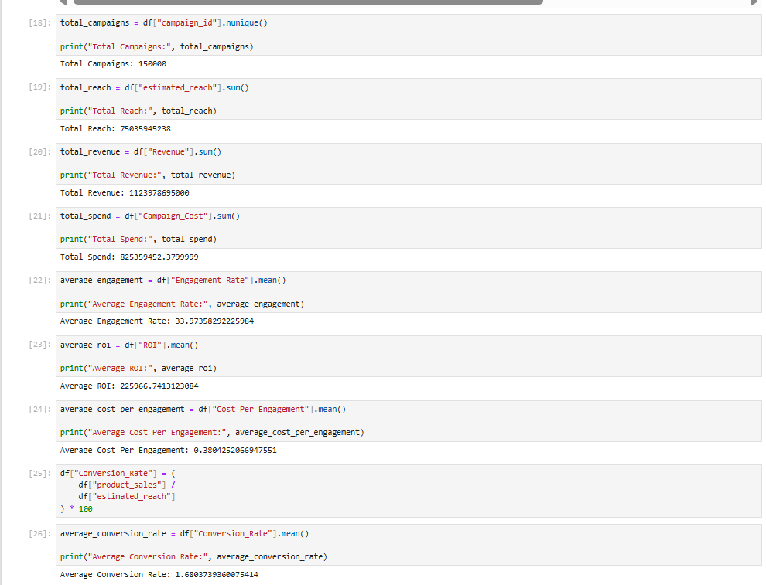
PHASE:3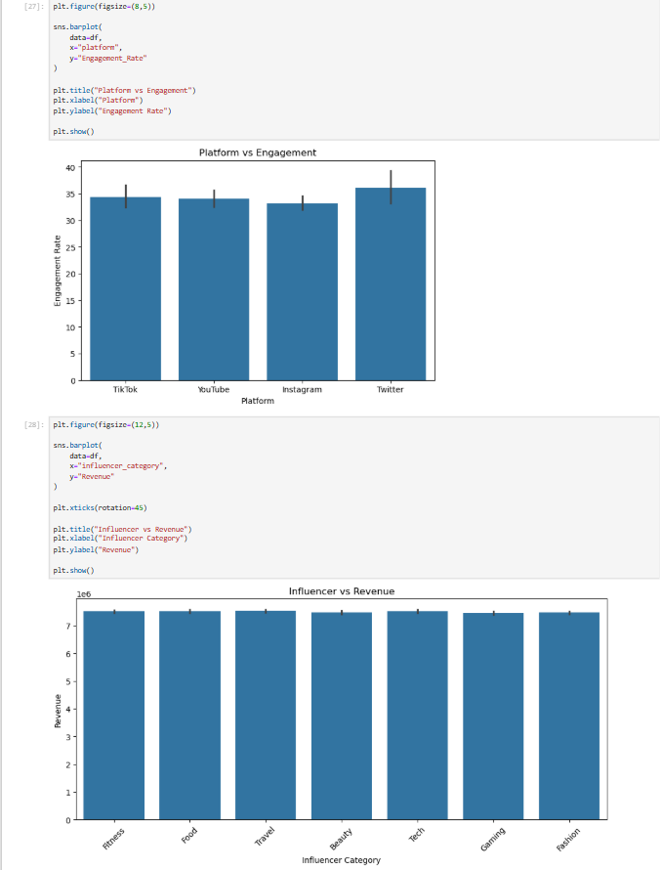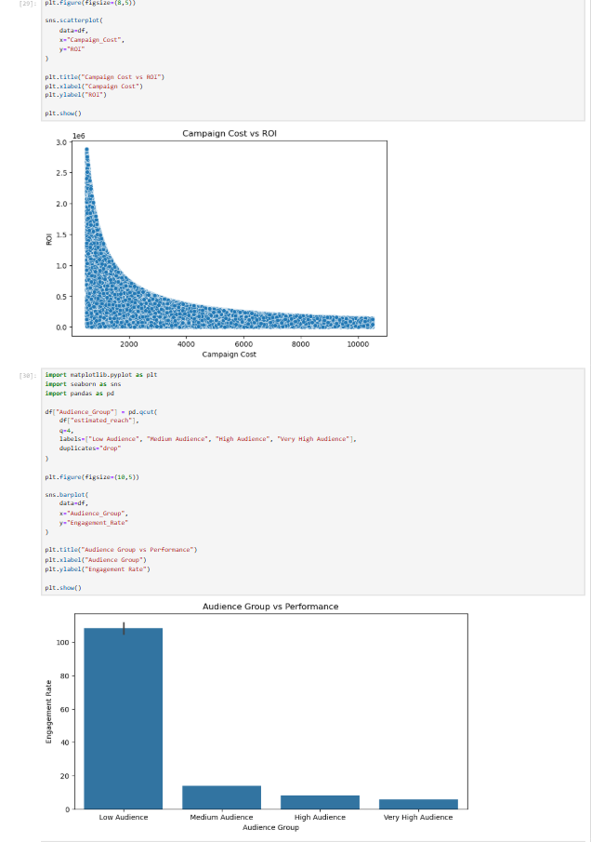
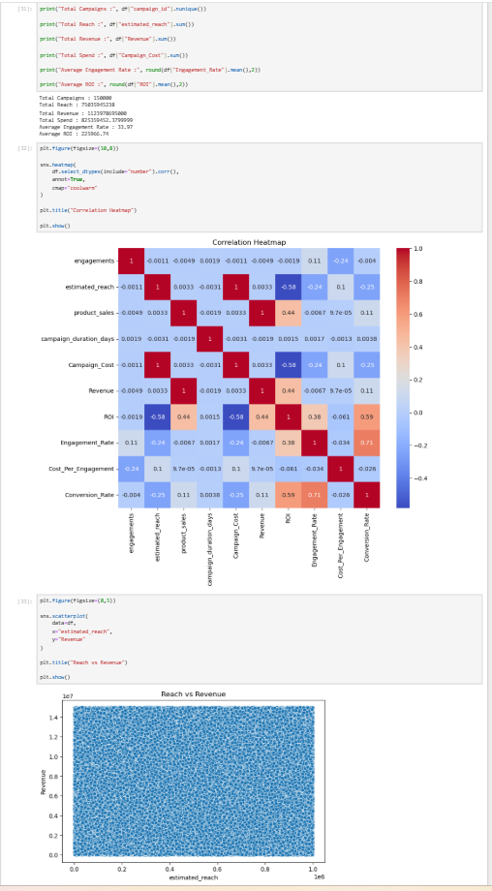
PHASE 4:
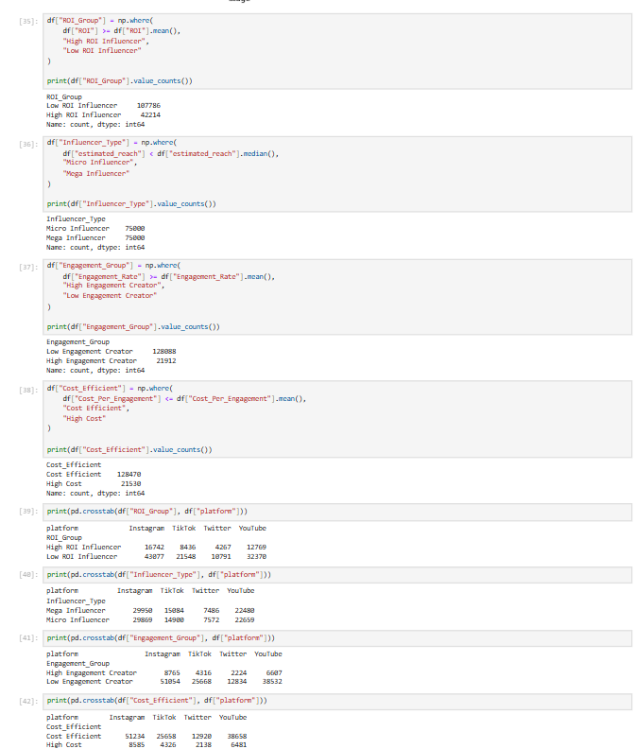

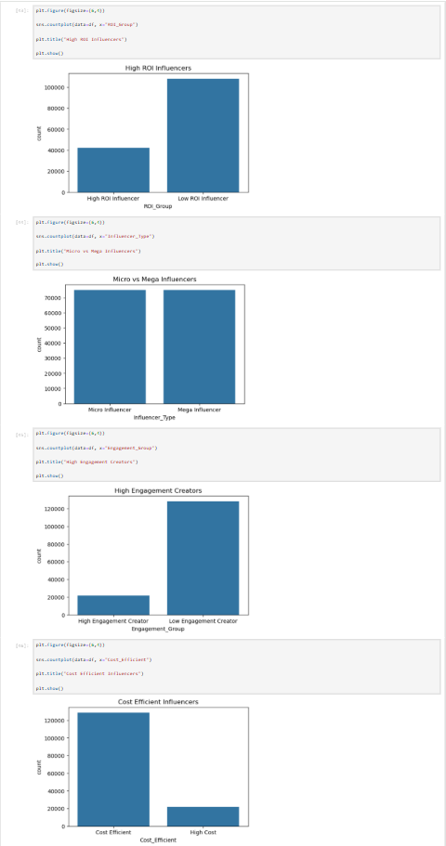

PHASE 5:
- executive overview dashboard:
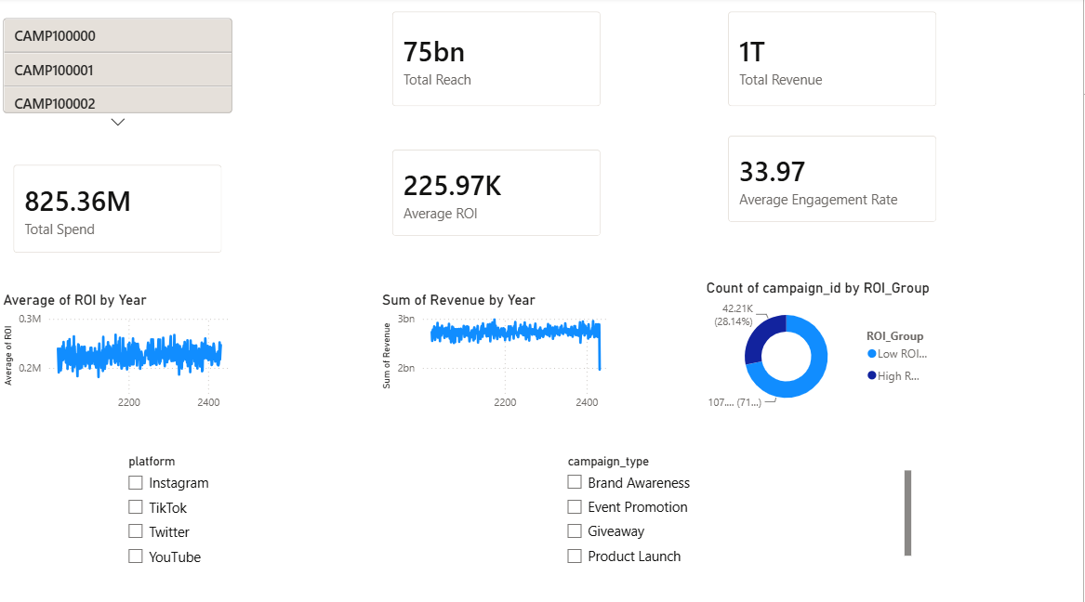

- Influencer Dashboard: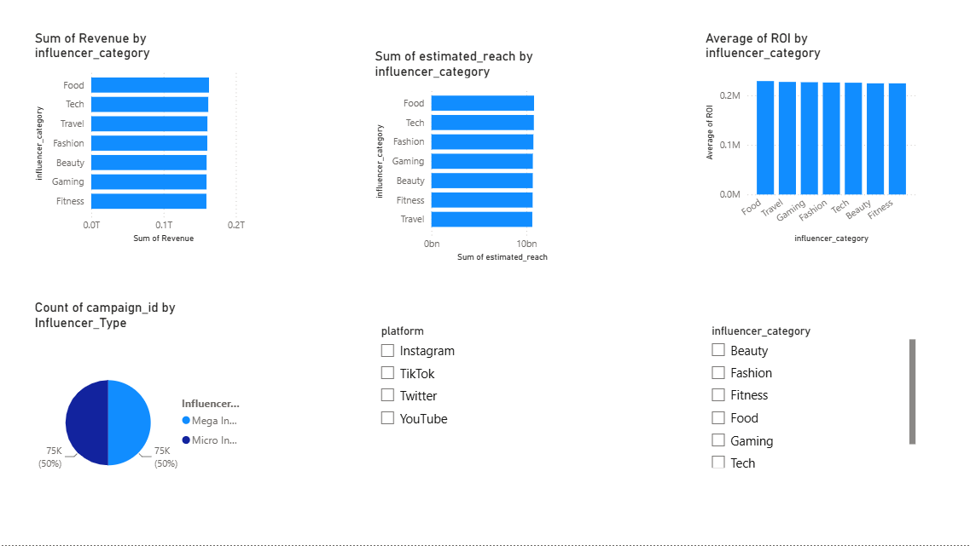
- Platform Dashboard:

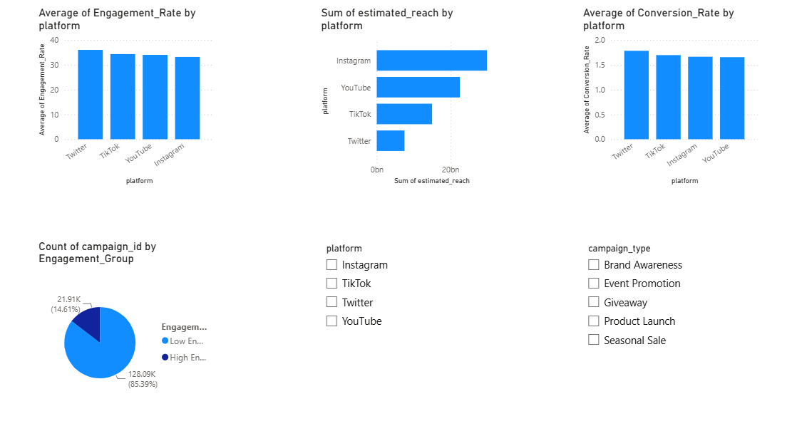
- Financial Dashboard:

